*FOR IMMEDIATE RELEASE*

 | 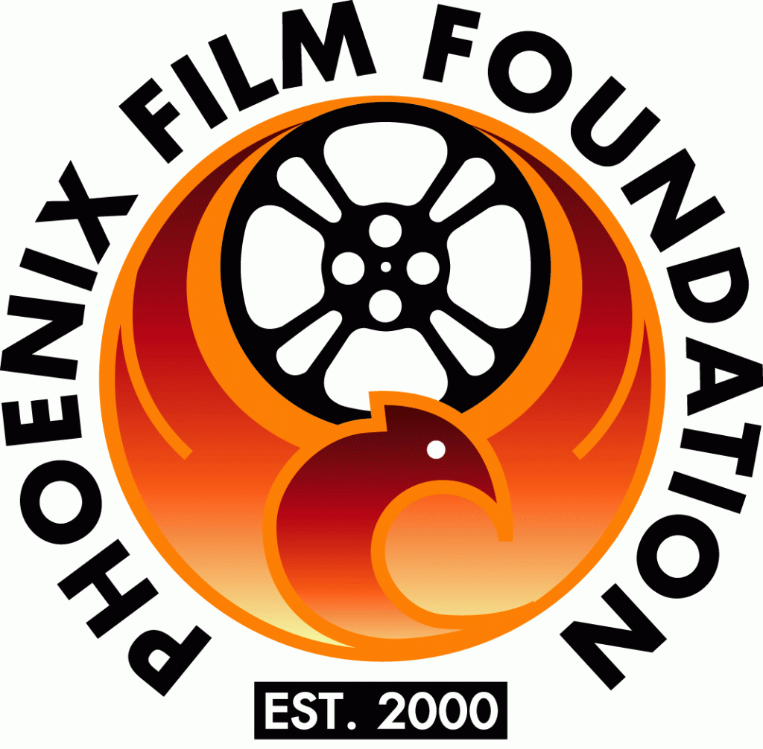 |  | 

PHOENIX FILM FESTIVAL ANNOUNCES THE INAUGURAL PEORIA FILM FEST TO BE HELD IN OCTOBER OF 2018

PEORIA, AZ, Wednesday, July 18 – The Phoenix Film Foundation and Phoenix Film Festival are thrilled to announce the start of a brand new festival. The Peoria Film Fest presented by the City of Peoria will be held October 19 to 21, 2018 at the Harkins Arrowhead Fountains 18 Theatre in Peoria, AZ.

“We couldn’t be prouder of what we’ve achieved over the last 18 years with the Phoenix Film Festival and our year-round film education and screening events.” said Phoenix Film Foundation Executive Director Jason Carney. “We’ve been looking to host an event in the North Valley and Peoria made the most sense. The growth of the City of the Peoria combined with the gorgeous Harkins Arrowhead Fountains 18 Theatre gives us a great backdrop to showcase some amazing new films.”

The event will be held over three days; screening a mix of independent and upcoming studio releases.

The Peoria Film Fest is also excited to partner with the City of Peoria as the festival’s Presenting Partner of the event.

“The City of Peoria is thrilled to host the Film Foundation’s October film festival,” said Mayor Cathy Carlat. “Peoria is an exceptional community, and with the nationally ranked Huntington University Arizona Center for Digital Media Art in our lively P83 district, our community is the perfect backdrop for this iconic festival. We look forward to welcoming the talented film and production companies who make this event successful, and the many cinematic enthusiasts to the heart of the North Valley.”

You can stay up to date on the festival at PeoriaFilmFest.com

About Phoenix Film Foundation
The Phoenix Film Foundation is a 501c3 Non-profit Organization whose mission is to support and develop the artistic appreciation, educational opportunities and growth of independent film within Arizona. The Foundation’s primary functions through its programs are to promote the exhibition of independent films and conduct educational programs that teach the art of independent filmmaking.

FOR FURTHER MEDIA INQUIRIES, PLEASE CONTACT:
Leigh Ann Dolan
480-513-3195
LeighAnn@phxfilm.com
###

